New HMS Webpage: About Us 13/02/2013
(Page 1)

HMS 90TH ANNIVERSARY

The year 2013 marks the ninetieth anniversary of the Haslemere Musical Society which was started modestly in 1923 by a local music teacher Annie Bristow.

One of her pupils was Jill Pite, long-time secretary of HMS, who has recorded her early memories of the Society which rehearsed in the Haslemere Hall before any of the modern comforts had been installed. In those early days the orchestra rehearsed first. Anthony Barnard, the conductor, then rehearsed the choir by which time he was so cold he had to be given two baked potatoes to warm his hands.

Since that time the Society, still comprising an amateur orchestra and choir, has gone from strength to strength and now offers the opportunity for audiences to hear live concerts of a high standard and for members to indulge in singing and playing under professional guidance. Rehearsals take place in the Haslemere Hall on Monday evenings at 7.30 pm from September until May with open sessions in June.

If you are a singer or an instrumentalist and are interested in joining the choir please contact Sue Ecclestone T: 01428 605612 or to join the orchestra contact Marion Bagshaw T: 01428 656129

Members are amateur players and singers, while the Director of Music, Leader of the Orchestra, Choir Master and Soloists are professional appointments.

New members, both singers and instrumentalists are always welcome bringing enthusiasm, commitment and a love of music.

(Page 2)
Musical Director

James Ross

Conductor James Ross won scholarships to Harrow School in London and to Christ Church at Oxford University. There he studied history, a master's degree in music and a doctorate on French opera under Roger Parker, winning the Sir Donald Tovey Prize.

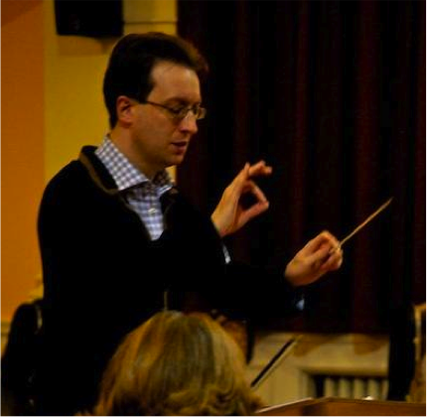

He was a finalist in the BBC Philharmonic Orchestra's 1998 Conducting Competition; since then he has conducted in Austria, Belgium, Bosnia, Canada, China, Czech Republic, France, Hungary, Italy, Serbia, Spain, Sri Lanka and the USA, and gave his first concert in Bulgaria with the Sofia Philharmonic Orchestra, National Choir in 2011 and the Haslemere Musical Society HMS.
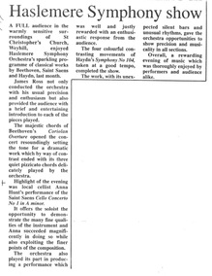
“James Ross not only conducted with his usual precision and enthusiasm, but also provided a brief and entertaining introduction to each of the pieces played”. The Haslemere Herald, 4 Nov 2011.

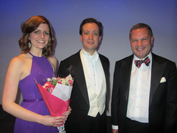

He is Music Director of Haslemere Symphony Orchestra and Chorus as well as; Sidcup Symphony Orchestra in South London, Oxford’s Christ Church Festival Orchestra, The Oxford Opera Company, Welwyn Garden City Orchestra and Chorus and Bridgnorth Sinfonia.

Previous positions include with St Albans Symphony Orchestra, of which he is now a Vice-President, and Oxford University Sinfonietta. He has performed in leading UK concert halls, including Symphony Hall, Birmingham, St. John's Smith Square, London, and the Sheldonian Theatre, Oxford.
He has conducted over 850 works, ranging from the Baroque, most core symphonic and choral repertoire, to contemporary music by Boulez, Ligeti, Stockhausen and many more
In the last ten years, James Ross has helped raise over £150,000 through concert-giving for charities including Whizz-Kidz, Addaction, Rethink, The Fund for Epilepsy, NSPCC, Response International, UNICEF, Sunera Foundation of Sri Lanka and Oxfam. Most recently, he presented a concert in aid of the Sunera Foundation and the UK-Sri Lanka Traumi Group with Danielle de Niese and Rohan de Silva at St John's Smith Square, London.

He is a member of the Performers and Composers Section of the Incorporated Society of Musicians (UK), of the Conductors Guild (USA) and League of American Orchestras.

(Page 3)
Chorus Master

Christopher Hann

Christopher is building a reputation as an accomplished choral conductor. In
addition to being Chorus Master for HMS he is also the Musical Director of
Harpenden Music Makers, Bookham Choral Society, The Cappella Singers and Dieci Voices, a professional vocal ensemble he co-founded in 2006.

Christopher is also The Joyful Company of Singers’ Conducting Fellow for their 2012 / 2013 season. Other Choirs he has worked with include; the BBC Singers, The Choir of Brompton Oratory, Glasgow University Chapel Choir, Royal Hollloway Chapel Choir, The Paisley Festival Chorus, The RAM Chamber choir and The National Boys Choir of Scotland Junior Corps. In addition to his work with the National Youth Training Choir, Christopher is also manager of Laudibus (The National Youth Chamber Choir) who recently won a Grammy for best Choral Performance.

He has recently completed a two-year Masters course in Choral Conducting at The Royal Academy of Music studying with Patrick Russill and Paul Brough. He completed his undergraduate degree in Vocal Studies at The Royal Scottish Academy of Music and Drama, studying with Stephen Robertson.

In addition to his conducting Christopher is in great demand as a professional consort singer. He currently sings with a number of professional ensembles including Polyphony, The Eric Whitacre Singers, Ex Cathedra, Philharmonia Voices, Dunedin Consort, Cappella Nova and Ludus Baroque, as well as singing in some of London’s premier Church and Cathedral Choirs, such as St Paul’s Cathedral, St Georges Chapel Windsor, The Tower of London, St Brides Fleet Street and Brompton Oratory. Plans for the coming months include; concerts in Belfast and Amsterdam with Polyphony, and a recording of new works by John Tavener and James MacMillan with Cappella Nova.

(Page 4)
Orchestra Leader

Tom Horn
Tom began learning the violin from a very early age and through his youth has played with Youth Orchestras in Kent, Channel Islands and in London. Most notably Tom was leader of the London Schools Symphony Orchestra, which enabled him to work with world-renowned artists such as Thomas Sanderling, Alexandre Markov and Robbie Coltrane.
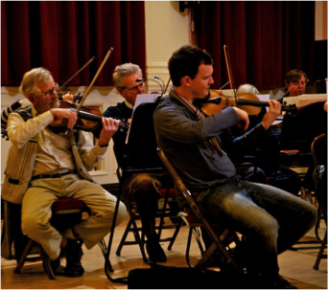
In 2003 Tom went to study music with Acoustics at Southampton University, he quickly surrounded him-self with everything musical and became the leader distant conductor of both the Symphony Orchestra and the Sinfonietta Orchestra. Tom also set up his own orchestra, the 'concerto ensemble' performing works both old and new, one of the pieces written for the ensemble was a Jazz piano concerto, by contemporary jazz musician Tom Marlow.
Tom has played with various orchestras and in numerous venues all over the world. In 2004 he formed the 'Stellar Quartet', with whom he has played at many functions and concerts, and performed for HRH the Duke of Edinburgh, Betty Boothroyd and John Williams. The eclectic mix of chamber music that Tom has performed and recorded ranges from Mozart and Dutilleux to compositions written for the quartet by contemporary composers. His latest project is performing an arrangement of 'KidA' by Radiohead with electronics, which is going to be taken to the Edinburgh festival.
After gaining one of the highest performance marks at the University Tom is now a freelance violinist and teacher in North London; he is continuing his studies with various tutors of differing musical styles, throughout the country. He hopes to continue performing and conducting with projects he has set up, such as the 'Charity Symphony Orchestra'. The largest project in the pipeline is the 'Haydenathon' where all 104 symphonies will be played back to back.

(Page 5)

Pianist at rehearsals: Clive Osgood
Clive (MA Mmus PGCE ARCO) is Director of Music and Organist at St Bartholomew's Church, Haslemere.
After completing his undergraduate studies at Bangor University, Clive Osgood undertook an MA in Musicology at the University of Cardiff. He was then awarded an organ scholarship at Salisbury Cathedral before training to be a teacher in London. He is currently completing a doctorate in composition at the University of Surrey, Guildford.
His compositions include instrumental, chamber and choral music as well as musicals. He has had music performed in several Cathedrals including St Paul's and Westminster Abbey. In 2006 his anthem 'Do not Fear' was performed on the Sunday Worship programme on Radio 4. His other recent compositions include a setting of the 'Stabat Mater', and a piano quintet. He is currently working on a string quartet.

(Page 6)
Orchestra members

(Page 7)
Choir members

Ann Budd
B Phyllis urton
Wanda Child-Thomas
Christopher Scholfield
David Dowdeswell
Pamela de Pledge
Evelyn Dent
Christine Ewing
Susan Farley
Rita Flower
Barbara Goulston
Linda Harris
Linden Hazelwood
Jackie Inskip
John Jackson
Felicity Jeffcote
Thea Jourdan
Kathryn Pearsall
Clare Laughton
Joe Mcdonald
Kate McWhirter
Barbara Miller

Nick Morrice
Martin Muncaster
Lara O'Keeffe
Elizabeth Owen
Richard Parker
John Pocock
Veronica Powell
Pauline Prior
Anne Rogers
David Salt
Diana Samways
Peter Sharpe
Thelma Slade
S Angela tinson
Stinson David
Susanna Brown
Virginia Taylor
Catriona Tremlett
Georgina Trout
Alison Wallis
Charles Warner
Seb Welford
Robert Whiteley

(Page 8)
Past Events & reviews
For Pictures taken at some of these concerts - see Gallery page.
2012
Orchestra and Chorus December 8th 2012 Flyer
Orchestra 13th October 2012 Flyer
Orchestra and Chorus May 5th 2012 Flyer
Orchestra and Chorus March 3rd 2012 Flyer
Orchestra and Chorus March 3rd 2012 Review
Press release for Long Journey Home recording
Press release for Hindhead tunnel opening concert
2011
Orchestra and Chorus, December 3rd 2011
Orchestra and Chorus, December 3rd 2011 REVIEW (PDF)
Orchestra, October 15th 2011
Orchestra and Chorus, May 7th 2011
Orchestra and Chorus, May 7th 2011 REVIEW (PDF)
Orchestra and Chorus, March 5th 2011 (PDF)
Orchestra and Chorus, March 5th 2011 REVIEW (PDF)
2010
Orchestra and Chorus, December 4th 2010 (PDF)
Orchestra and Chorus, December 4th 2010 REVIEW (PDF)
Orchestra and Chorus, May 8th 2010
Orchestra and Chorus: The Creation, 6th March 2010 (PDF)
Chamber Orchestra Concert, 6th February 2010 (PDF)
2009
Orchestra and Chorus, December 5th 2009 (the Hallelujah Chorus)
Come and Sing - Puccini Messa di Gloria, 26th September 2009
Orchestra and Chorus, 16th May 2009
Orchestra and Chorus: St. John Passion, 28th March 2009 (PDF)
Orchestral concert, 7th March 2009
Come and Sing: Vivaldi Gloria, 7th February 2009
2008
Orchestra and Chorus, 6th December 2008
Orchestra and Chorus, 10th May 2008
Orchestra and Chorus, 1st March 2008
2007
Orchestra and Chorus, 8th December 2007

